The Choice Methodology:
A New Foundation of Structured Machine Life

by Christopher A. Tucker

Department of Cybernetics, University of Reading,
Whiteknights, Reading RG6 6AH, UK

Abstract:

Foundations of machine life are necessary to facilitate their evolution from rudimentary forms. Although numerous forms exist today, a proper architecture of similitude, laws, and operands needs to be authored to establish baselines for generational development of the artificial life form. This paper will demarcate the structural properties of a synthetic brain dependent upon choice and survival to illustrate a rudimentary cognitive paradigm. The goal of this paper is set a theoretical foundation to understand the synthetic mind.

—3.920 words—
Introduction

An artificial life form is one that exists in architecture, portrayed in physical hardware and software, while imbuing the aspect of an organic form it is intended to mimic. In order for it to be a successful organism, it must be privy to the most basic of functions all organic forms take for granted. Two of the most salient of these is choice and survival. Survival is dependent upon intelligent manipulation of the collective inventory of objects available in a particular environmental setting and defined by the choices that are made to facilitate it. A successful being that makes the right choices survives to pass its knowledge onto subsequent generations. Therefore, choice is a critical power in a living system. This feature, along with a survival mechanism, must be in place for a machine to qualify as an artificial life form.

It is the goal this research to understand what artificial life is by mimicking it in a particular form. I argue that life cannot be determined without first subjecting it to the phenomena common to all life forms regardless of their categorization. It is currently a commonly held theory in biology that life forms differ only in the type of algorithms used to process information and respond to contrasting scenarios and choices. So it is reasonable to argue a life form is only categorized by its behavior and its behavior is dependent upon the type of algorithm formed in the surviving structure. Supposing this assumption is true, I offer one more condition; that the being must have the will (choose) to integrate the behavior into its being. It is from here where I will start the discussion of my concept.

Development—Theory, Foundation, & Intelligence

Considering the rapidly advancing development of the independent robotic platform and its evolution into higher forms of synthesis, it is relevant to establish a criteria with which to gauge and facilitate such development. We need a place to start analysis to understand the synthetic mind. It has been argued in the field of cybernetics that the pinnacle of robotic development, depicted in science fiction and what is slowly becoming a realization of science, lies in the manifestation of a system of cognition or in metaphysical terms a consciousness. But how do we go about knowing what is a cognitive system? How do we quantitatively describe it without using qualifiers? The properties commonly ascribed to any object are, in last analysis, names for its behavior. How to we categorize an artificial life form and how would be know what to call it when we see it?

Theoretical Assumptions

If a machine is given the ability to make choices and as a consequence of those choices, have the ability to die (directly experience entropy), will it foster emergence—manifest behaviors not accounted for in theory or experiment? The following three assumptions are postulated from this question:

#1: If a machine mimics biological life, it has access to those kinds of experiences attributed to it,
#2: if a machine can make a choice, it portrays some level of consciousness,
#3: if a machine has knowledge of its death, it fosters emergent behavior.

To accomplish this goal, an explicit definition must be employed. At this point, we cannot define cognition of a particular system without using a contrasting characterization. I begin with three assumptions that will drive the research methodology.

#1: If a machine mimics biological life, it has access to those kinds of experiences attributed to it.

The tenets of biologically-inspired robotics are founded on the principle of robots that mimic typified life forms. The foundation is divided into two principles: 1) attempts to create functional robots based on living systems, 2) creating robots to understand biological systems. The arguments in this paper are engaged in the first principle since I am interested in creating functional, autonomous robots free from human interference. The machine must resemble an animal in form and function but at this stage in the research, I am only concerned with function. The first step is to come up with a typography of lifeforms so that we can ascribe the relevant behavior necessary to the type of machine desired. Figure 1 shows a table of the differences of form and mimic.

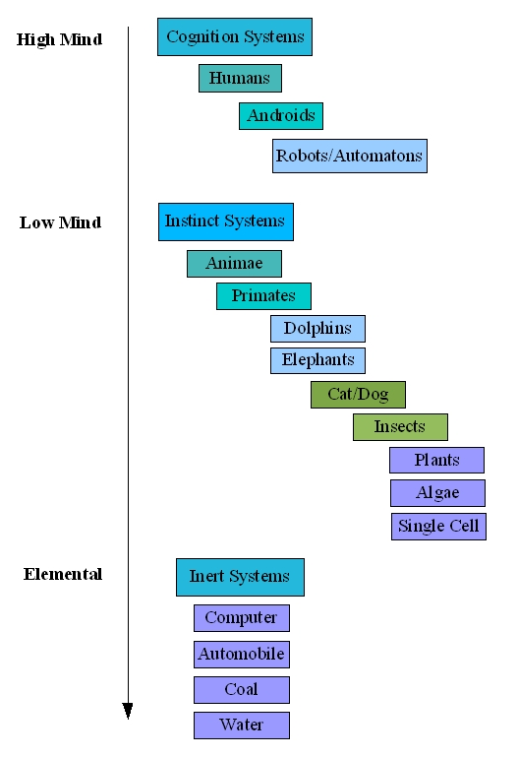
Figure 1: A Cognition Hierarchy

Figure 1 is a hierarchy of objects available to all systems comprising this planetary body (a closed system). It is organized by decreasing emphasis in ascribed intelligence. I have divided up the continuum of life into three major categories: Cognition, Instinct, and Inert. Within the categories are subcategories contrasted within their complexity. For example, in the cognition group, humans are at the top of the hierarchy because of their contrasting complexity to the other members in the group. Androids are lesser as they are designed to mimic humans but are not necessarily privy to the level of complexity manifest in humans, dependent upon the current level of technological development. Robots and automatons fill the rest of the category as they are less complex than androids but more complex than the members of the instinct group. At the top of the hierarchy of instinct systems are animae. Animae are synthesized animals. Ideally and dependent upon the cleverness of the programmer, they are more complex than the other members of its group. Animae can be in the form of cats, dogs, or other synthetic animals. Animae is the best place to start investigating questions of the properties of what is a synthetic life-form; they are complex enough to inspire interesting research questions. Currently in artificial intelligence, these pursuits are done in instinct systems which may or may not yield interesting enough results for purposes of artificial life. However, it still maybe quaint (high enough in the list) to try to understand agents (particulates of intelligence) of artificial entities in computing environments. It should be noted that a third system does exist within the frame of this definition, the inert. In a physical sense, the inert plays only a peripheral role to both systems; however, in a metaphysical sense, the inert plays a crucial role in completing the cycle of living systems contextually within their environment. They aid in ascribing and formulating behavior strategies. For the latter feature and in pursuit of a complete research question, the inert will be considered. Intelligence is a sub-property of each system and can be arranged in a hierarchical form by the entities that fill each of them. This arrangement is by no means authoritative but serves to illustrate the difference between organic and inorganic systems and where the concept of life may be contextually understood.

For the purposes of the research, I make the assumption that cognition is a state of self-actualization. We, as humans, know this phenomenon only from our own experience and can only approximate the experience of others, including other types of living systems. This, however, should not prevent a broader definition since our degree of approximation is limited by the definition itself. Firstly, there is a line of demarcation between a cognitive system and an instinctive system. A cognitive system is the result of a complex evolution of an individual's experience and an instinctive system is the result of the propagation of genetic information between generations of living entities. Secondly, a cognitive system has the ability to extend beyond the quantity of genetic information of an instinctive system and expresses a qualitative difference. Thirdly, this qualitative difference gives rise to two equal yet distinct states of being—the high mind and the low mind. Therefore, cognition is the ability to direct changes on continuous events. Instinct is the inability to cognitively affect the outcome of continuous events. Although there are anomalies that may traverse the definition dependent upon empathetic qualification, I argue it holds for most entities.

#2: If a machine can make a choice, it portrays some level of consciousness.

Analysis: The Choice Complex

The question regarding choice is: can a machine make a choice and if it did, would it be a meaningful one? On the condition that artificial life is no different that organic life, if an organism is dependent upon its survival and purpose, i.e., obeys the law of entropy, then it must by default make choices regarding the success or failure of its species. This mechanism is the characteristic theory of evolution. If a species could not make the proper choices, adapt to changing conditions, then it will become extinct. This feature needs to be extended to artificial life forms to see if the quality of artificial life is real or an imagined property in cybernetics. I argue this is the only way to know for certain whether or not the forms are alive and prone to the forces of evolution. An architecture should be designed that sets the purpose of the machine and its behavior as an emergent property exhibited in its choices.

How is behavior generated from architecture, how can the intellectual link be made? I argue that all we can test scientifically is the concreteness of a finite system which is comprised only of a series of choices that determine the life or death of an organism. I extend this argument to synthetic machines for if they are to be considered truly alive, then they must obey the basic condition that they can die and that they have knowledge of it. In biology, this trait of death is of a decreasingly loss of faculties or entropy, or in physics, the decay of energy in a system.

In the case of choice, there is the work of William Grey Walter. His experiments were the result of his curiosity of how the brain resulted behavior. To this end, he constructed three-wheeled automatons donned with lights that searched out other lights. They were analog devices which used triodes and amplified feedback to mimic types of behavior. The feedback between the circuits caused the machine to display four distinct types of behavior qualified by the observer. The problem with Walter’s analysis was that many of his assumptions were not tested outside of his own research and when they were in the late 1990s by Owen Holland, many of Walter’s assumptions were wanting. However, what is interesting here is Walter’s notion of “free-will”, or choice, exhibited in his machines.

In commentary from O. Holland:

In his writings about the tortoises, Grey Walter gave much weight to an attribute he called ‘internal stability’—the claimed ability of the tortoises to maintain their battery charge within limits by recharging themselves when necessary. A feature of the tortoises’ circuitry was that, as the batteries became exhausted, the amplifier gain decreased, making it increasingly difficult to produce behavior pattern N (negative phototropism).
Holland (2003, p. 2108-9)

Which is the attribute to avoid the light in the charging station where the ‘feeding’ took place. I am extending this notion to the theory presented in this paper and the following design for an experiment.

#3: If a machine has knowledge of its death, it fosters emergent behavior.

This theoretical assumption is simple: If a machine know it can die, this knowledge and direct access in manipulating it physically, will cause emergent behavior. Emergence is a property apart from the collection of quantification of its parts. In the following section, I will delineate a design that will facilitate the principles set forth in this methodology.

Research and Methodology: Architecture and Design

The design of the artificial life system is firstly defined as a series of goal-based assumptions that guide the development of the methodology. I will outline a set of four goals that will foster a successful synthetic animal or animae.

The first goal of a successful cybernetic system is that it should be fully autonomous. That is, once the system is started, it should require no further input from an external source or operator. In order to be autonomous, the system should be self-sufficient; i.e., have all the components necessary for its operation installed, variable in component and configuration depending on the expertise of the engineer. But when the system is brought online, it should run continuously and without fail.

The second goal of a successful cybernetic system is that it should exist in situ or in context with its environment. It must be able to access experience from a native stimuli-response model with which to compose unique algorithms.

The third goal of a successful cybernetic system is that it should possess a system of behaviors relevant to its being. It should also have the ability to evolve and eventually reproduce.

The fourth goal of a successful cybernetic system is that it must be in behavior indistinguishable from any other living system it mimics.

Subsequent to these assumptions, there are two physical systems that must be in place to fulfill the three assumptions and the four goals. These two systems, or artificial life models for consideration, are the hardware and the software system.

The Hardware Paradigm

I offer the following experimental design to empirically test the notion of choice, survival, and the possible consequence of emergent behavior. I designed the Featured Power Environment as a means to substantively give the machine the ability to make a choice between types of operational power necessary to its onboard components. The hardware design is based on transformational, structural logic approach. I argue that an understanding of such a transformation logic system will illustrate empirically the relation of choice to behavior in the machine and to test whether or not the notion of the survival complex is a mechanism that will lead to emergent properties. The general schematic of the system is illustrated in Figure 2.
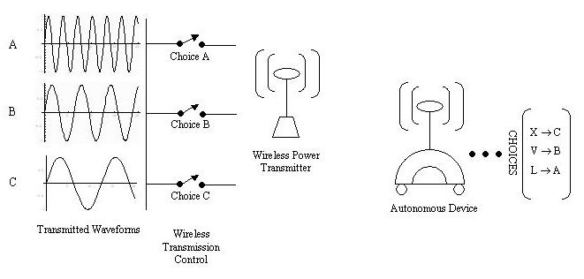
Figure 2: Featured Power

The waveforms to the left of the figure are a spectral view of the transmission representing the total power in watts. The spectral forms are real power to be consumed by the machine. Depending on its current task and necessary power to perform its programmed task, the machine is allowed to estimate its consumption and make a choice as to the type and amount of power it needs. Listed to the right of the figure, Level ‘A’ is the highest power level energizing all onboard systems. ‘B’ is mid-range powering motor functions and a some sensors. ‘C’ is sleep mode. These three hierarchical functions form a trinary computational system in addition to the more generalized binary modes of the generic computing device.

There are three modes of operation for the device shown in Figure 2. Sleep, average, and high power represented by C, B, and A respectively. At a given time, the machine receives a level of power necessary for its operation. For example, if a general-purpose robot has a power consumption rating of 15VDC with a current draw of 0.125A, it is necessary to calculate the consumed power at an instantaneous time in watts:

P_{s} = E x I or 1.875W

Considering the type of transmission and the necessity to transmit only the proper amount of power, a pulsed system would be preferred to a constant wave (CW) system to have the machine consume power at intervals instead of in a stream. Nevertheless, a pulse period of 10ns should suffice to power onboard components. Clock speed of the processing bus (for example 100MHz) should be made to agree with the pulse period to keep the power flow symmetric with its computational speed. In this way, unless the power is used by a loaded circuit, it will not transmit more than the quantity we have set for it by the frequency of the wave. For example, the power of each waveform is:

Waveform A: 15 volts x 1.0 amperes = 15 watts,
Waveform B: 15 volts x 0.500 amperes = 7.5 watts,
Waveform C: 15 volts x 0.200 amperes = 3 watts.

In the early part of the experiments, I will expect to send a higher quantity of power than what is anticipated by the mathematics. This is to account for loss in the transmission (the method is prone to some leakage), changes in the charge environment of the laboratory, and to resonate with the likelihood of feedback on the transmission.

One of the most striking features of this design is that experiments can be conducted continuously and without limit. As long as the transmission system is powered, the machine will remain online. In this way an equilibrium can establish a baseline between life and death. If the machine does not make the right choices to enhance its survival, it turns off and effectively dies. If it does not send the proper signal to the transmitter, it will not receive the proper power. A small capacitor contains enough charge to keep it active for a 90k mS countdown once the power is too low or not available for it to further perform. The experience gained from its life cycle is held in a volatile memory device that will be erased if the power is off. An additional strength of the design is since it remains online continuously, observation of long-term behaviors can lead to advances in understanding artificial ethological concepts in the model under examination. The physical realization of entropy is designed to be an add-on to the existing general robotics platform. Called the Entropic Circuit, it is part of what I term a domain-specific robotics platform, similar in breadth and scope to a domain-specific computing language. It is illustrated in Figure 3.

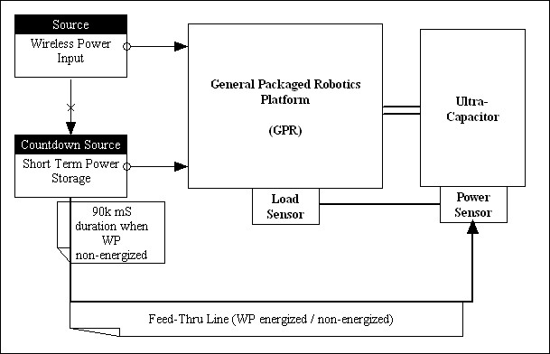
Figure 3: Entropic Circuit in Domain-Specific Robotics Platform

The Software Paradigm

The software architecture possesses the same transformation-logic array of the hardware model. The software paradigm is a modular, domain-specific programming language; it parses, sorts, scripts, compiles to objects, transforms, and generates input and output channels. A domain-specific language (DSL) is created specifically to solve problems in a particular domain and, in the general case, is not designed to solve problems outside of it. In contrast, a general-purpose language (GPL) is designed to solve problems in many domains with an extensive toolbox that does not necessarily focus on the specific case. Many DSLs do not compile to byte-code or executable code like GPLs, but to various kinds of objects. DSLs have exposed APIs that can be accessed from other programming languages without breaking the flow of execution or calling a separate process. Thus, they can be designed to operate as programming libraries.

The domain in this specific case is a synthesized core governed by a parametric equation 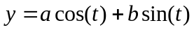on a limit between 0 and 4, whose solution generates objects, tables, data structures, tools, and transformations. It additionally manifests channels that allow generic software to compile against its libraries. In this way, it seamlessly integrates with the generic robotics platform and its onboard default language set.

The domain consists of the following members: 1) data elements, 2) tables, 3) parameters, 4) engine (virtual processor), 5) assimilation mechanism—the absorption of data from external data sources such as a remote server or computing nexus. A further breakdown of how each of the members fits into the composite schema can be seen in Figure 4.

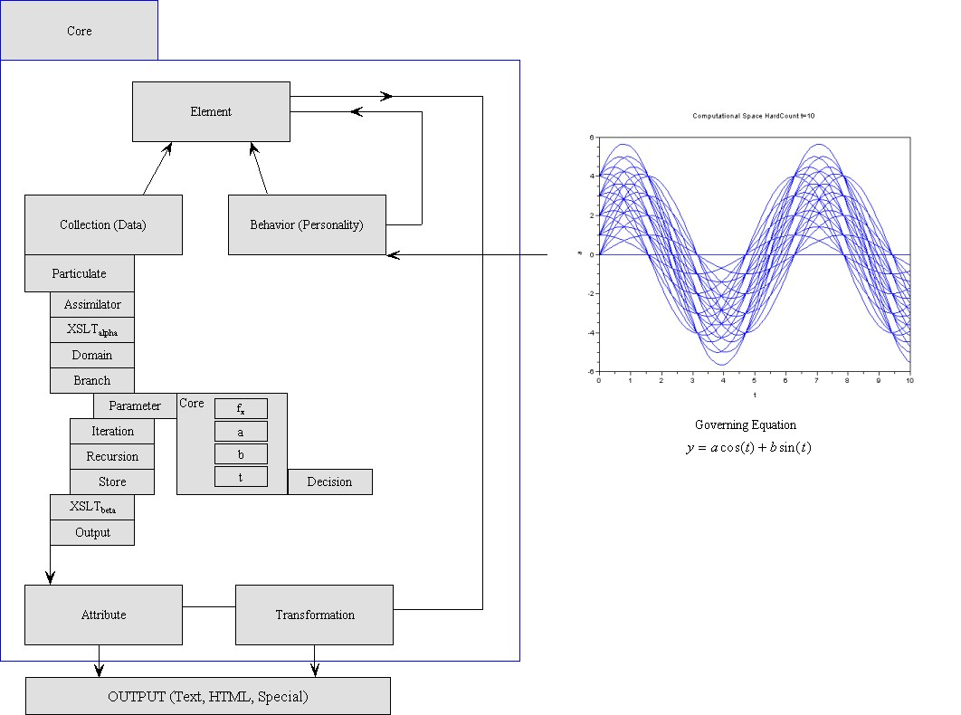
Figure 4: Transformation Logic with Governing Equation (Template)

This domain-specific language has been designed to support the hardware model. It is a mirror of the hardware logic and uses the same transformation-based approach of the physical system. In this system, the governing equation defines the solution set the system will iterate through, or the “personality” of the machine.

The software uses a general information processing architecture gleaning its source from sensor data. The core compiler is a series of inputs, transformations, and outputs to motor and decision-making centers. In this way, the system is independent and free from human intervention internally apart from the initial conditioning or implementation of the starter program that will provide the machine its beginning point and tasks to perform during its life cycle.

The entire system is designed to be as general as possible save the specific components demarcated in this paper. The system can be deployed in a general-purpose robot such as Qrio, Aibo, Asimo, or RoboSapien, with minor modification of the pipe logic of available on-board sensors and locomotive processes. It is my vision that I will be performing the experiments and testing the apparatus for a subsequent paper: Artificial Life: Behavior, Choice, and Entropy. Technologically speaking, the system is written in Ruby using Gems, XML, XSLT as data transformation logic, and SQL as store and Ajax as data object manipulation. It is still under development and its architecture is currently under test.
Conclusion

What I have described in this paper is a new methodology to not only describe and quantify artificial life but illustrate a method how to do perform concrete, empirical experiments. I have discussed several unique types of technology, many of which have not been deployed in such a manner. It is the pinnacle of our technological development that we create machines in simpatico with ourselves. In this way we not only come to the understanding about unknown phenomena and manifestation, but also glean insight into the structure of the world around us.

A machine would come to realize, if made to be intelligent enough, that it has the power to control its own life and death. I have argued this would spawn emergent behavior in response to the control of choice. Whether or not it understands the choice is for data and experiment; many humans themselves make and implement choices without knowing the reasons why. I believe it is this essence of experience that makes life so enticing to be lived, for good or for bad. In this paper, I do not discriminate between organic life and artificial life; in fact, for the purposes of the theory, concepts such as life, experience, and death apply equally to both systems.

I have often been asked how my work bridges the gap between artificial intelligence (AI) and artificial life (AL). I offer the answer given by Rodney Brooks, creator of the subsumption architecture, and who’s current work is trying to understand the properties of cognition:

Researchers in artificial intelligence (AI) and artificial life (Alife) are interested in understanding the properties of living organisms so that they can build artificial systems that exhibit these properties for useful purposes. AI researchers are interested mostly in perception, cognition and generation of action, whereas Alife focuses on evolution, reproduction, morphogenesis and metabolism. Neither of these disciplines is a conventional science; rather, they are a mixture of science and engineering. Despite, or perhaps because of, this hybrid structure, both disciplines have been very successful and our world is full of their products.

I offer this methodology, theory, and research project. The products are animae or synthetic animals and by constructing them we can not only understand the types of life embodied in such forms, but be on track to understanding ourselves.

Acknowledgements

I would like to thank the Institute of Information Theory and Automation, Prague, Czech Republic (http://www.utia.cas.cz) for support of this paper.

References – Literature Survey

Albus, J.S., "Outline for a Thoery of Intelligence," Proc. of IEEE Systems, Man and Cybernetics, 21(3), 473-509, May/June 1991.

Arkin, Ronald. Behavior-Based Robotics. Cambridge: The MIT Press. 1998.

Ashby, Ross, W. An Introduction to Cybernetics. London: Chapman & Hall, Ltd. 1957.

Bateson, Melissa, Susan D. Healy, and T. Andrew Hurly. "Irrational Choices in Hummingbird Foraging Behavior", Animal Behavior, 63, 587-596, 2002.

Brooks, Rodney. "The Relationship Between Matter and Life", Nature. v409, n6818, pp. 409-411. (2001).

Dick, Philip, K. Do Androids Dream of Electric Sheep? Boston: Penguin Books. 1968.

Fagan, Brian, M. World Prehistory: A Brief Introduction, Sixth Edition. Prentice Hall, New York. 2004.

Ferrier, James Frederick. An Introduction to the Philosophy of Consciousness. Blackwood's Magazine, Edinburgh, 1838-39.

Hicks, David, L., Uffe K. Wiil. "Research in Structural Computing". Journal of Network and Computer Applications, London, UK, Vol. 26, Issue 1, January 2003, pp. 3-9.

Holland, Owen & David McFarland. Artificial Ethology. Oxford: Oxford University Press. 2001.

Holland, Owen. "Exploration and High Adventure: The Legacy of Grey Walter". The Royal Society, 20 August 2003.

Langdon, Chris, G. What is Artificial Life? http://zooland.alife.org/.

Maslow, Abraham, H. Toward a Psychology of Being, 3rd Edition. New York: Wiley. 1998.

McFarland, David. Animal Behavior. Menlo Park: The Benjamin/Cummings Publishing Company, Inc. 1985.

Melear, C. "Low-Power Techniques for Modular Processors. WESCON/94. Idea/Microelectronics. 27-29 Sept 1994.

Mitchell, Tom, M. Machine Learning. New York: McGraw-Hill. 1997.

Ripley, B.D. Pattern Recognition and Neural Networks. Oxford: Cambridge University Press. 1995.

Ratanaswasd, P, Chris Garber, Adrian Lauf. "Situation-Based Stimuli Response in a Humanoid Robot". Fifth International Conference on Development and Learning (ICDL), Bloomington, IN, 31 May - 3 June 2006.

Stapleton, Olaf. Sirius. New York: Random House. 1944.

Van Deursen, A. "Domain-Specific Languages verses Object-Oriented Frameworks", SmallTalk and Java in Industry and Academia, STJA'97, pp. 35-39.

Vaitis, M, M. Tzagarakis, K. Grivas, E. Chrysochoos. "Some Notes on Behavior in Structural Computing". Second Meta-Informatics Symposium, Graz, Austria. April 2003.

Walter, Grey, W. The Living Brain. New York: W.W. Norton & Company. 1953a.

Walter, W.G. Accomplishments of an artefact. BNI Papers, Science Museum. 1953b.

Walter (1953a, pp. 65-7).
Brooks (2001, p. 410).
BBC Discovery 21.10.06
Albus (1991, pp. 473-509).
Herrick.
Walter (1953a, pp.120-1).
Holland (2003, p. 2116).
Walter (1953a, pp. 120-1).
Maslow. (1968, pp. 10-24).
Bateson, Healy, & Hurly (2002, pp. 587-8).
Holland (2003, pp. 2098-2111).
Holland (2003, p. 2107).
Walter (1953a, p. 290).
Ashby (1957, pp. 161-90).
Melear (1994, 438-43).
Van Deursen, pp. 35-39. Also WikiPedia under the keyword “domain-specific language”.
Brooks (2001, p. 409).

